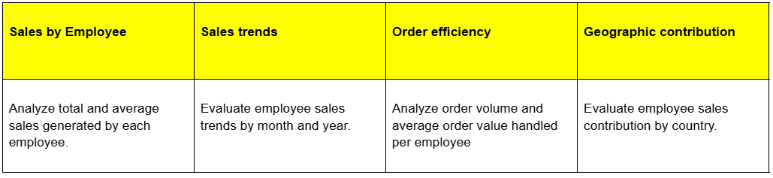
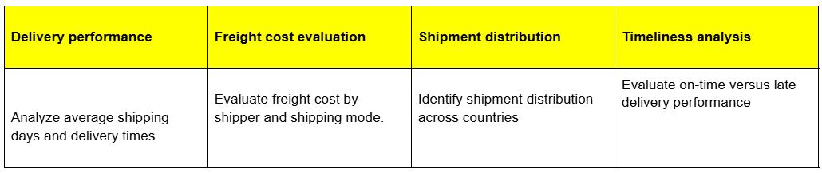
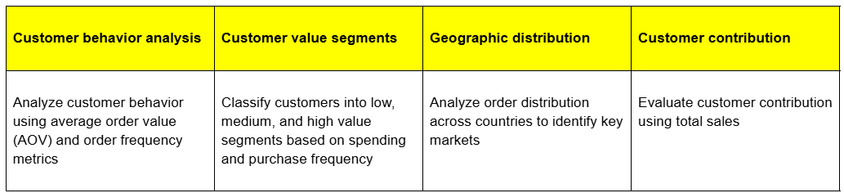
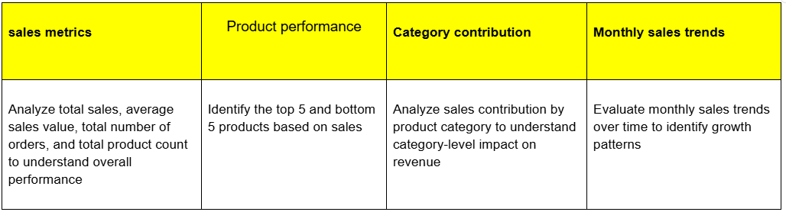
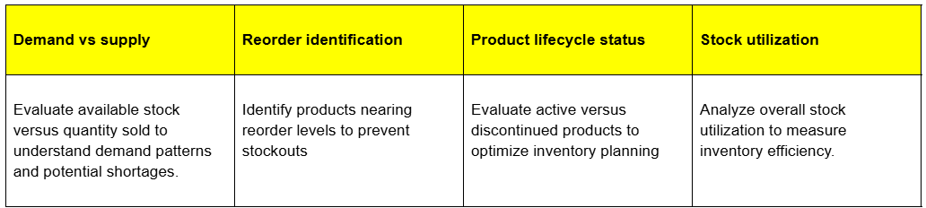
Northwind Traders
Sales dataset
Employee Performance
Shipping
Inventory Analysis
Customer Segmentation
Sales Analysis

